Press release 12. 5. 2021
16th Pragueshorts Film Festival: Coming 2 to 27 June

The 16th Pragueshorts Film Festival, organized by the team behind the Karlovy Vary International Film Festival and featuring nearly 120 films, will take place from 2 to 27 June 2021 online and at cinemas.
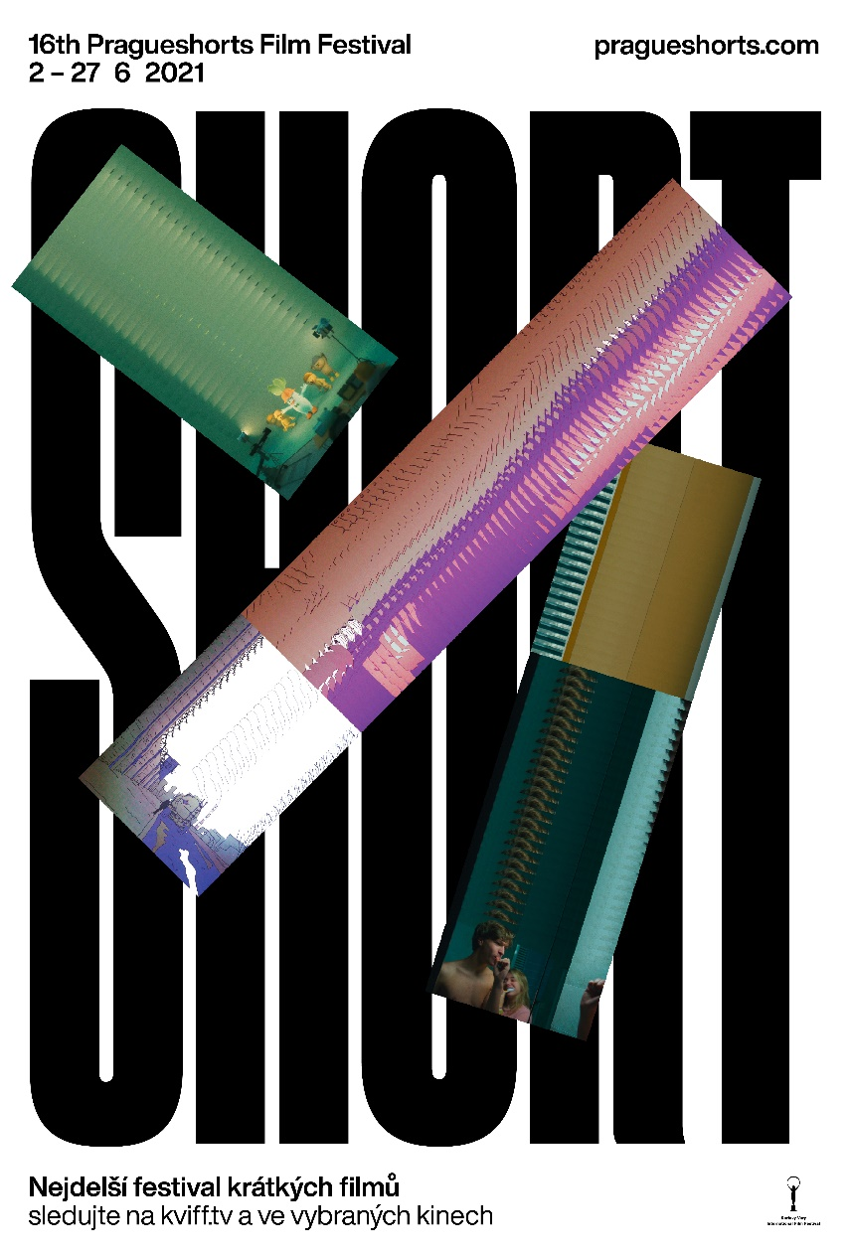
The festival offers the best new international short films, the most interesting works by Czech directors, a moderated midnight program, comedies, ultrashort films, visual experiments, a block of films by Radu Jude (winner of this year’s Golden Bear at the Berlinale), a set of short films featuring Jenovéfa Boková, and a lockdown hit by Jirka Mádl – all available for free from the comfort of your home on our new platform www.kviff.tv. At the same time, the festival program will come to 11 cinemas in Prague and a number of cinemas throughout the country.
Jiří Bartoška, president of the Karlovy Vary International Film Festival, says: “For this year’s short film festival, we have chosen a summer date and, in view of the current situation, an unusual format that combines online presentations with classical screenings. One thing that is not changing, however, is our attractive program of films showing that tales full of emotions, suspense, or humor can be told even on a smaller scale. We believe that the sixteenth edition of Pragueshorts will become one of the first Czech film festivals to be held this year and that it can offer interesting cinematic experiences to both live and virtual audiences.”
The International Competition features 37 films, including the Czech film Anatomy of a Czech Afternoon by director Adam Martinec, the Romanian-Czech Along Came a Prince by Cristina Groșan, and the American animated series 2 Lizards about two reptiles amidst the first Covid wave in New York, which premiered in spring 2020 on Instagram and is now in the permanent exhibition of New York’s Museum of Modern Art. The International Competition jury will present one award for Best Film, which comes with a financial prize of 3,000 Euros, plus two honorable mentions. In the National Competition, viewers can look forward to eight films, which will vie for the Best Domestic Film award and a prize of 2,000 euros.
For the first time, this year’s LABO section of experimental films will be a competition section, with a jury of Czech artists choosing from among nine entrants. Besides the traditional Audience Award, which is open to films from across the entire festival program, viewers of our online platform can also choose the festival’s best ultrashort film. The block of films by Radu Jude presents five of his live-action shorts plus an autobiographical documentary in which Jude reflects on his career and his artistic style. Another section is titled 5x Jenovéfa, and as the name suggests it features five films with actress Jenovéfa Boková made between 1998 and 2019. And finally, the program wouldn’t be complete without our traditional moderated Brutal Relax Show of horror and the bizarre.
The visuals for the 16th Prague Short Film Festival were designed by Zuzana Lednická of Studio Najbrt, who describes the idea behind the graphic design as follows: “The visual design for the 16th Pragueshorts Film Festival is based on film scenes that generate new images on the movie screen of our mind. Get ready for another dose of imagination!”

The 16th Pragueshorts Film Festival will take place from 2 to 27 June 2021 at www.kviff.tv at select cinemas.
Print-quality photographs for the various sections, plus other visuals are available for download here:
http://pragueshorts.com/cs/media

More at www.pragueshorts.com.

Media contact:
Zuzana Janáková, press@pragueshorts.com, +420 724 577 576

